

**Locker Rental Website**

**Ahmed Alharbi**

**Colton Buster**

**Prepared for Dr. Harold Nelson**

**Department of Computer Science**

**December 13, 2019**

Contents

Abstract 3

Introduction 3

Problem 3

Scope 3

Motivation 4

Design 4

Functional Requirements 4

Non-functional Requirements 4

Use Cases 5

User 6

Administrator 6

User Interface 7

Home 7

Registration 8

Login 9

Booking 10

User Dashboard 10

Admin Login 11

Admin Dashboard 12

Database 13

Implementation 14

Completion Process 15

Conclusion and Future Work 15

Appendices 16

Progress Reports 16

Individual Contribution 17

# Abstract

Our objective for this project was to create a proof-of-concept for a locker rentals website to be used on campus. We sought to create a site that would allow students to register with an account associated with their SMU email address, then book TUB lockers using that account. We also created a separate administrator login for monitoring site usage, maintaining locker inventory, and modifying student account information when necessary.

We hope this project can be a stepping stone to introducing a similar feature on the existing SMU website. A page dedicated to locker rentals with the ability to process payment would increase student awareness (I am a commuter student and was unaware of this service offered by the university until this year) and expedite the current, tedious process.

# Introduction

## Problem

Saint Martin’s University offers a locker rental service via the Trautman Union Building. Students can rent storage lockers at the beginning of each semester by speaking with the TUB front desk. Currently, there is no way for students to check availability without going to the TUB. Our solution allows students to access these rental services via the web.

## Scope

Our site enables students to view all available lockers and make a booking online. An administrator can add, remove, and edit locker information, view student usage of the site, and accept students’ rental requests. Currently, payments cannot be made via the site, but we hope to add this functionality in the future.

## Motivation

We wanted to create a project that would benefit the university in a meaningful way by expediting the locker rental process on campus. A project of this scale could be reasonably completed within the timeframe of the semester.

# Design

## Functional Requirements

1. The system allows registration of an administrator with id, username, email, and password as required inputs.
2. The system lists all lockers and allows the admin to add, delete, and update.
3. The system allows the admin to monitor and edit rental records.
4. The system lists all students and allows the admin to manage them.
5. The system allows students to register using id, username, email, and password.
6. The system allows students to modify account information.
7. The system only accepts Saint Martin’s University email addresses and verifies registration with a code.
8. The system shows available and booked lockers to students.
9. The system allows students to book available lockers.

## Non-functional Requirements

1. Easy to use
2. Visually appealing
3. Easily scalable to accommodate additional lockers
4. Useful administrator tools

## Use Cases

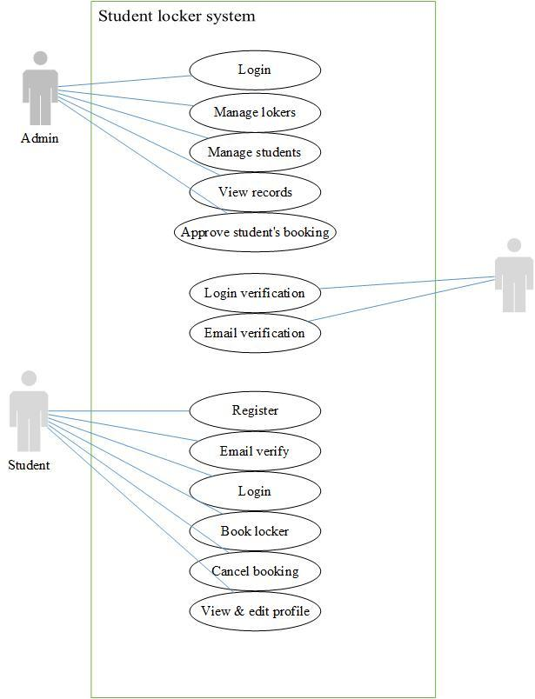

### User

The user is the primary agent that interacts with the system. The user has access to the home page, registration page, login page, and booking page. The user can log into the site or create a new account, browse available lockers, and select one to book.

### Administrator

The administrator has full access to the site. They can view all pages that the user can see, plus additional pages for monitoring the site. There is a separate login for administrators that takes them to the dashboard, which displays pertinent information such as the total number of users, total number of bookings, number of active users, and number of lockers. From this page, the administrator can add or delete lockers, update a locker’s status (available, booked, or damaged), view records, approve student rentals, and manage student account information.

## User Interface

### Home

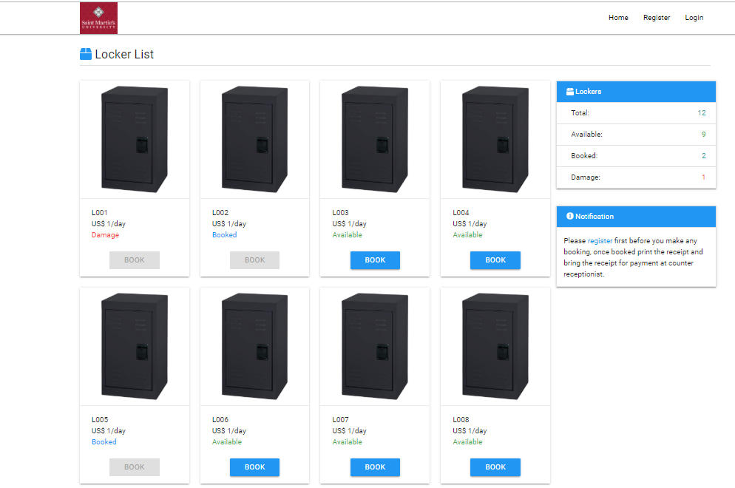

The home page displays the full list of lockers. Each locker has a picture tile that displays its number, price, and status, with a booking button below. On the top right, there are buttons to return home, register, and login (this bar is available on all pages accessible by the user). There is also a reminder to register prior to booking farther down the screen on the right. Pressing the “book” button when not logged in will send the user to the login/registration page.

### Registration

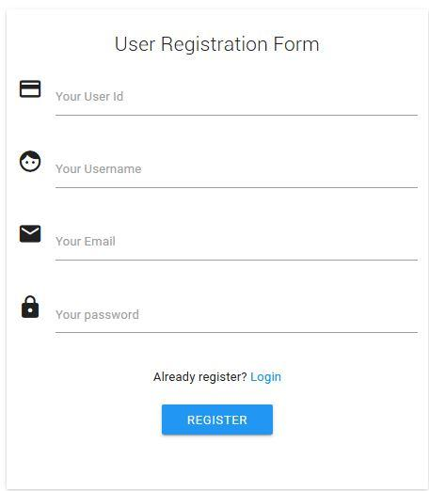

The registration page can be accessed from the home and login pages. It includes fields for user id, username, email, and password. Upon registering, a confirmation code will be sent to the email that is linked to the newly created account. Entering this code grants the user the ability to book a locker.

### Login

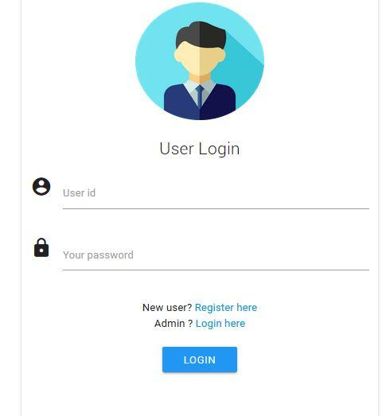

The login page is for returning users and those who have otherwise already logged in. It has fields for user id and password. It also includes a link to the registration page as well as the admin login page.

### Booking

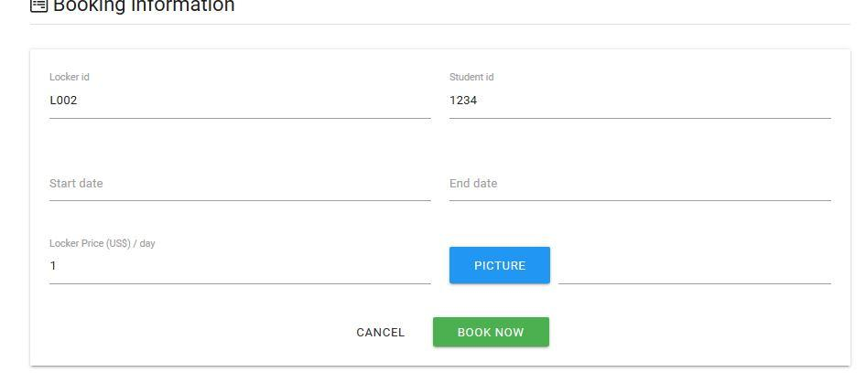

The booking page is accessible by users after they have registered an account with the site. It can be accessed by pressing any of the “book” buttons displayed beneath the locker tiles. It has fields for user id, locker number, and desired start and end date for the rental. Upon completion of booking, the receiver receives a message telling them that the booking was successfully completed.

### User Dashboard

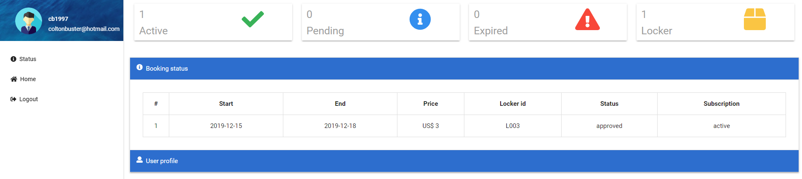

The user dashboard can be accessed after the user has registered with the site, and replaces the “Register” button on the main page. The dashboard shows the booking that was made and its status. Until approved by an administrator, the status will be pending. This page also includes a user profile tab that displays username and id, and allows the user to edit their account information.

### Admin Login

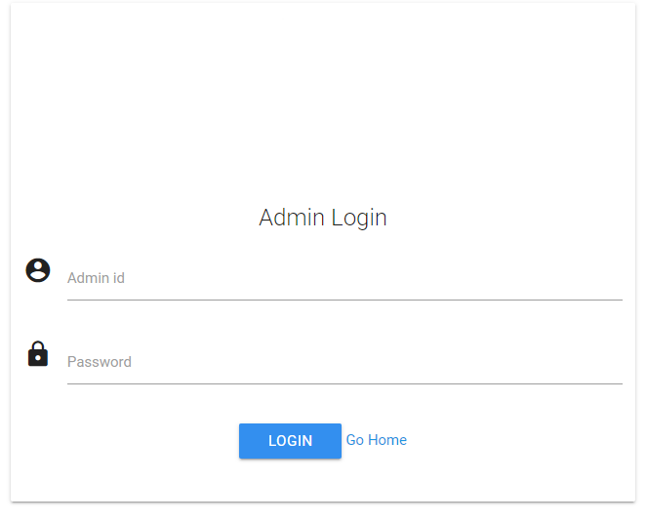

The admin login page can be accessed from the main login page. It has fields that require id and password, just like the normal login page. Logging in via this page will take the administrator to the dashboard.

### Admin Dashboard

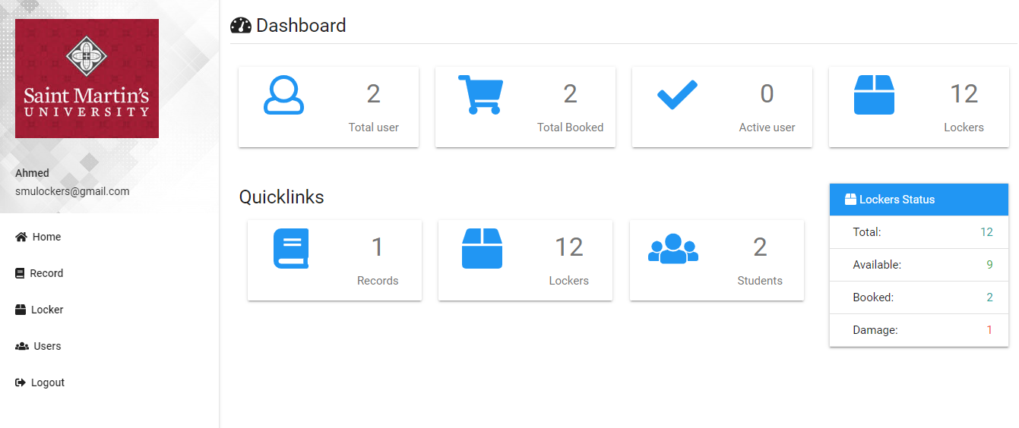

The admin dashboard includes information on the total number of users, lockers, and bookings, all active users, records, and user information. From here, the admin can add new lockers, remove current ones, change any locker’s status, approve a student’s rental request, and modify student’s account information. A bar on the left side has buttons corresponding to each of these actions.

## Database

The database is comprised of four tables: admin, locker, student, and record. Here is the SQL used to create each table:

**Admin Table**

CREATE TABLE `admin` (

`admin_id` varchar(15) NOT NULL,

`admin_username` varchar(255) NOT NULL,

`admin_email` varchar(30) NOT NULL,

`admin_phone` int(30) NOT NULL,

`admin_password` varchar(70) NOT NULL

) ENGINE=InnoDB DEFAULT CHARSET=latin1;

**Locker Table**

CREATE TABLE `locker` (

`locker_id` varchar(15) NOT NULL,

`locker_status` varchar(15) NOT NULL,

`locker_price` int(11) NOT NULL DEFAULT 1

) ENGINE=InnoDB DEFAULT CHARSET=latin1;

**Record Table**

CREATE TABLE `record` (

`record_id` int(11) NOT NULL,

`record_start` varchar(10) DEFAULT NULL,

`record_end` varchar(10) DEFAULT NULL,

`record_price` int(11) DEFAULT NULL,

`record_item` varchar(255) DEFAULT NULL,

`record_status` varchar(10) NOT NULL DEFAULT 'pending',

`record_sub` varchar(10) NOT NULL DEFAULT 'expired',

`record_approved_by` varchar(15) NOT NULL,

`student_id` varchar(15) NOT NULL,

`locker_id` varchar(15) NOT NULL

) ENGINE=InnoDB DEFAULT CHARSET=latin1;

**Student Table**

CREATE TABLE `student` (

`student_id` varchar(15) NOT NULL,

`student_username` varchar(100) NOT NULL,

`student_pwd` char(70) NOT NULL,

`student_email` varchar(30) NOT NULL,

`code` int(11) NOT NULL,

`verified` varchar(5) NOT NULL

) ENGINE=InnoDB DEFAULT CHARSET=latin1;

**Entity Relationship Diagram**

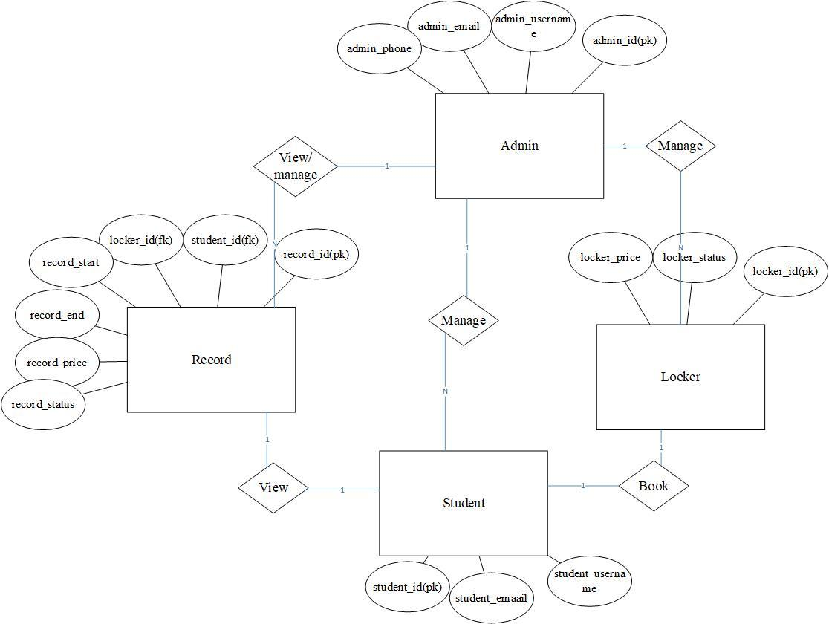

# Implementation

Our site is built using HTML, PHP, and CSS. We used HTML to create the webpages and forms and CSS for stylization. We connected our site to the database we built using MySQL via PHP. The site consists of 7 different webpages. It is run locally using XAMPP.

**Viewing the site:**

1. Download XAMPP (be sure to install Apache and MySQL modules)

2. Open the XAMPP control panel and start the Apache and MySQL modules

3. Open phpMyAdmin from the control panel

4. Go to the database tab and create database “lockersystem”

5. Import lockersystem sql file from DB folder in project file

6. Put the project file in the xampp/htdocs folder

7. Type localhost\lockersystem\index.php into your web browser

8. You are now at the home page of the locker rental site

## Completion Process

**Planned Schedule:**

|  |  |
| --- | --- |
| October 26 | Begin designing web pages |
| November 2 | Finish all forms and pages |
| November 9 | Add functionality to all forms |
| November 16 | Connect database to site |
| November 23 | Begin adding security |
| November 30 | Add payment method |
| December 7 | Host site |

**Actual Schedule:**

|  |  |
| --- | --- |
| October 26 | Home page |
| November 2 | Database |
| November 20 | Login/registration forms |
| November 26 | Dashboards |
| November 30 | Finalize design elements |
| December 3 | Connecting site to database via MySQLi |
| December 8 | Final admin features |

We failed to meet our schedule. Looking back, I think it was a bit too ambitious given the amount of time we had to complete the project as well as balancing the rest of our workload. There simply wasn’t enough time to learn all the necessary skills. I am happy with what we were able to accomplish, but having an additional semester would have been nice. We could have expanded the functionality of the site and added additional features.

# Conclusion and Future Work

Overall, the project was a success given the amount of time we had to complete it. We learned a lot about time management and the importance of communication. At times, especially as the semester was drawing to a close, we failed to meet as frequently as we did earlier in the semester. Both of us live off campus and had full course loads, so finding time when both of us could get together was difficult.

As for the project, I am happy with our work and think it is a great starting point for a system that the university could use. The skills we learned can also be applied to other projects as well. One of my friends does freelance photography and I am considering building a website for him. Though not directly related, I can use the work we’ve done thus far to help.

In the future, we would like to actually have our site hosted and give users the ability to pay online as well. We have the rest of the year to work on it, and Dr. Guimaraes expressed interest in helping us to continue the project.

# Appendices

## Progress Reports

1. **September 12**: Ahmed and I met to brainstorm ideas for the project. We don’t have a client yet but are looking for one, and I know a few people who might have something for us. We exchanged contact information and set up a folder in google drive for the project.
2. **September 26**: The client I had in mind fell through, but Ahmed had the idea of creating a website to help with locker rentals at the TUB. We decided to pursue this idea after clearing it with Dr. Nelson.
3. **October 11**: Ahmed met with Elizabeth Rumball, Assistant Director of Campus Life, to inquire about the locker system. We have a good idea of the requirements for the project now.
4. **October 23**: We prepared slides for the midterm presentation and finished the report. I was unable to access my Github repository so we put everything in Ahmed’s for now.
5. **November 13**: Many of the pages are done but are still very plain. We are unlikely to meet all of our design goals.
6. **November 24**: We met and discussed the work to do over Thanksgiving break. Namely, finishing the dashboards, cleaning up the site, and connecting the database.

## Individual Contribution

I was primarily responsible for the reports, presentation, and final essay while Ahmed wrote most of the code.